Project titlE:
Group No:
American International University-Kuwait
EC100 -Section 2

Final Design
No | Student Name |  | Student ID Number
1
2
3
4

Table of Contents
Step 1: Detailed drawing for final design 2
Step 2: Isometric drawing 3D (three dimensional) 3
Step 3: Three different views (Front, Top, right side) 2D (two dimensional) 6
Step 4: Detail design description (How it operates, details of materials, how it will be manufactured) 7
Step 5: Suggestion for improving the design. 9

Step 1: Detailed drawing for final design

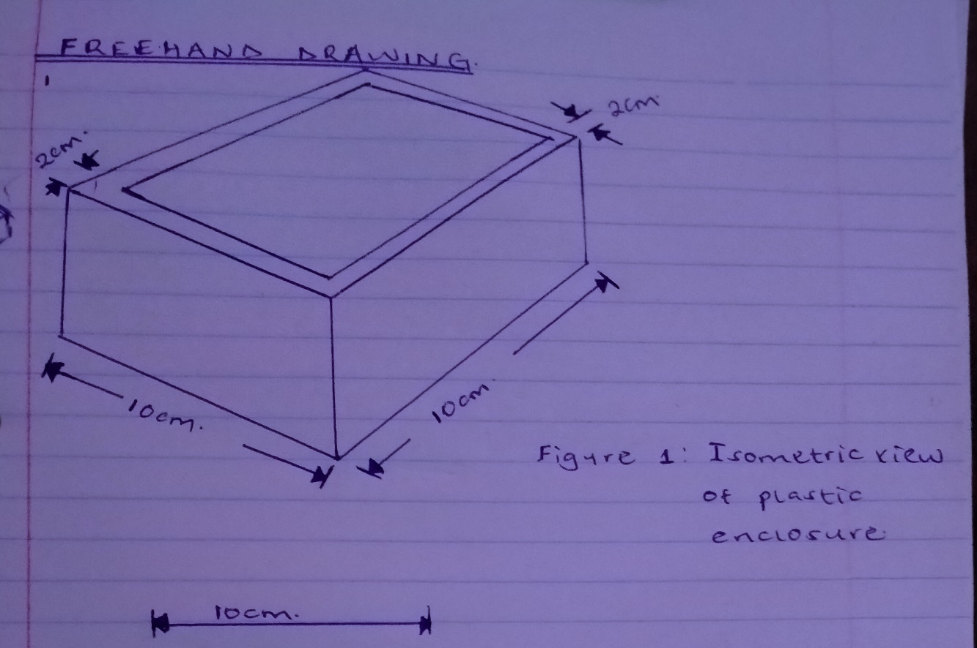
Figure showing the 2-D drawing of the enclosure used in this project.

Step 2: Isometric drawing 3D (three dimensional)

Figure showing the 2-D drawing of the enclosure used in this project.
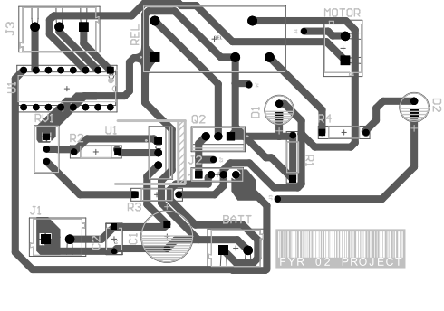
Figure showing the P.C.B layout drawing of this Aquaponics Project

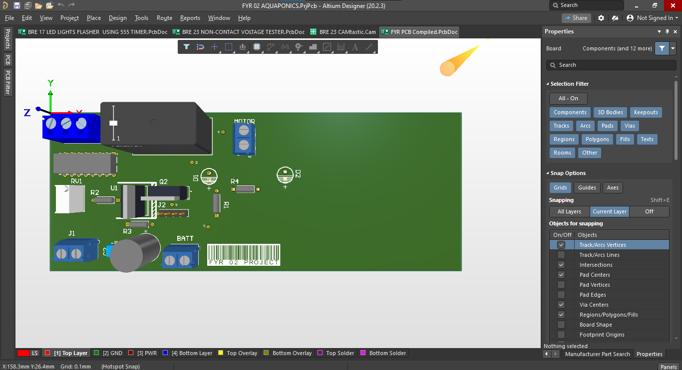
Figure showing the Circuit Layout using Altium Designer.

Step 3: Three different views (Front, Top, right side) 2D (two dimensional)

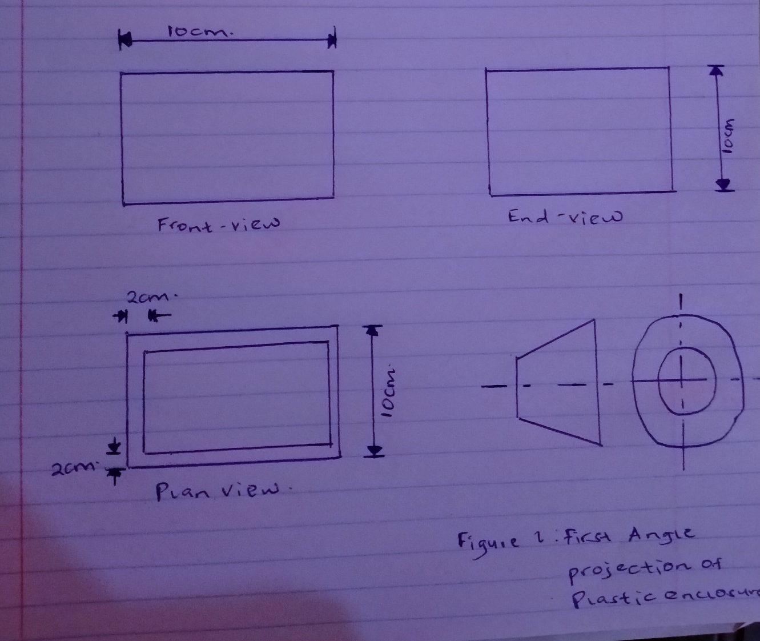
Figure showing the Plan, Front and End view of the Plastic enclosure from the First Angle projection.

Step 4: Detail design description (How it operates, details of materials, how it will be manufactured)

OPERATION
The aquaponics project works with four circuits; Battery charging circuit, LCD output, P.W.M Inverter and Motor control topologies. The working mechanism is that the renewable energy source provides the output power where the battery charging circuit serves to recharge the 12V battery, the same electrical energy goes to the Inverter for conversion from the D.C to the A.C while the motor control serves to drive the pump or the 12V motor. Summarized as;
1. Battery charging circuit for Power supply.
2. SPWM Inverter that changes the Solar Panel's DC output to an AC source.
3. PWM Motor Controls that runs a 12V motor (acting as a pump).
4. L.C.D Output that displays alphanumeric characters.

BILL OF MATERIALS
BILL OF MATERIALS (INVERTER CIRCUIT)
COMPONENT | AMOUNT
10KΩ resistor - 500mW | 1
150KΩ potentiometer | 1
100Ω resistor - 500mW | 1
1000µF electrolytic capacitor -25V | 1
2200µF electrolytic capacitor - 50V | 1
100nF ceramic capacitor | 1
555 IC | 1
240/12v 3A stepdown tx | 1
TIP 41 npn transistor | 1
TIP 42 pnp transistor | 1
Heatsink | 2
Breadboard | 1
Jumper cables
120kΩ resistor* | 1
BILL OF MATERIALS (BATTERY CHARGING CIRCUIT)
COMPONENT | AMOUNT
LM317 regulator | 1
Heatsink* | 1
1000µF electrolytic capacitor - 50V | 1
BC547 transistor | 1
0.22µF ceramic capacitor | 1
100Ω resistor - 500mW | 1
0.5Ω resistor - 1W (OR 1Ω*2) | 1
1N4007 rectifier diode | 1
0.22µF ceramic capacitor | 1
470Ω resistor - 500mW | 1
120Ω resistor - 500mW | 1
1KΩ potentiometer | 1
LED - green | 2
1KΩ resistor - 500mW | 1
BILL OF MATERIALS (12V TO 9V REGULATOR)
COMPONENT | AMOUNT
0.33µF ceramic capacitor | 1
0.1µF ceramic capacitor | 1
LM7809 regulator | 1
1N4007 rectifier diode | 1
Heatsink* | 1

MANUFACTURING PROCESS
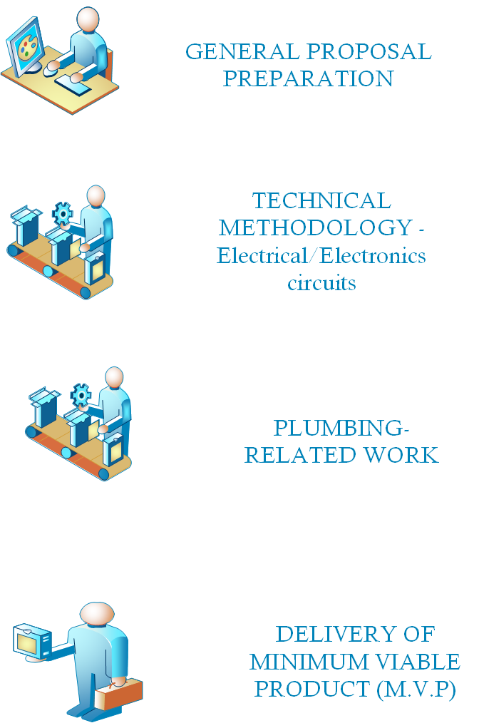

Figure showing the Manufacturing process for this product.

Step 5: Suggestion for improving the design.

The possible design modifications include;
- Support for other Microcontrollers with Internet of Things technology that takes the data to sync with the cloud for data collection and analysis.
- Artificial Intelligence; because the system works with data from the renewable energy source (Solar) it is good to include data science techniques to analyze the information from the panel for synthesis.

